- Naming Recommendation:
It might be nice to change estimated rental to estimated charge or estimated fee since the total includes not only the rental but also the surcharge, the cost of sale accessory and optional extra.

- Wrong trigger of creating a new reservation.
After a reservation is made, press modify to change the class of the truck. Select a truck that is not available, it will display the below message:
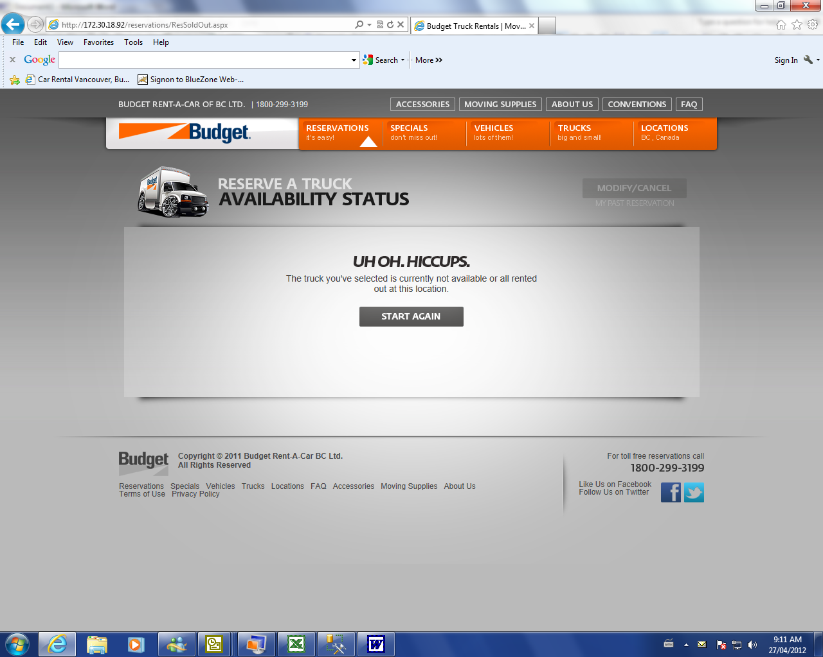
If I click “start again”, it will direct me back to the first page for the reservation and anything done after that is actually creating a new reservation instead of modifying the last one.

- Problem after modify optional extra and accessory sales.
After a reservation is made, select optional extra to modify. When next step on the page for optional extra is pressed, it will direct you to the sale accessory. Modify sale accessory and press next step and insert credit card information again. After that, press next step and the error below will be displayed.

Location Vancouver Kingsway:

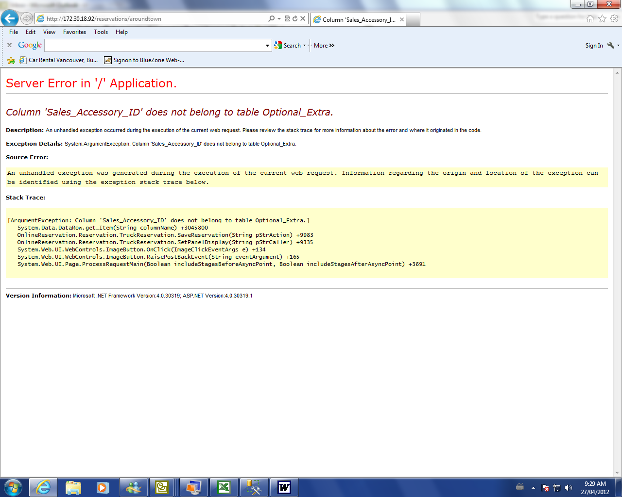

Location Abbotsford Downtown:
